Summer Reading Project DUE: ________________________________
Freshmen English 2012

Objective: Imagine your summer reading novel has been made into a full length featured film. Create a DVD cover of this new movie.

FRONT COVER
☐ Title of the book
☐ Author of the book
☐ 1 picture/photo that represents the setting or an important scene from the story (*this cannot be the actual
cover of the book)
☐ A tagline/important quote from the book

BACK COVER
☐ 3 Images that represent the
☐ 1) beginning
☐ 2) middle
☐ 3) ending of the book
☐ Summary of the book
☐ Two reviews or your novel made feature film (how did it make you feel? Would you recommend it? Why?)
☐ 1 positive review
☐ 1 negative review

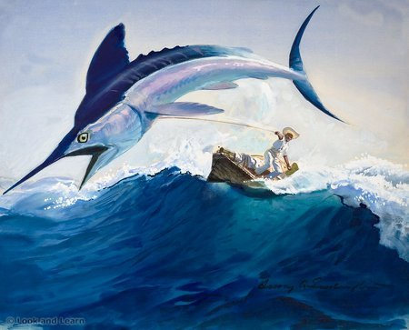
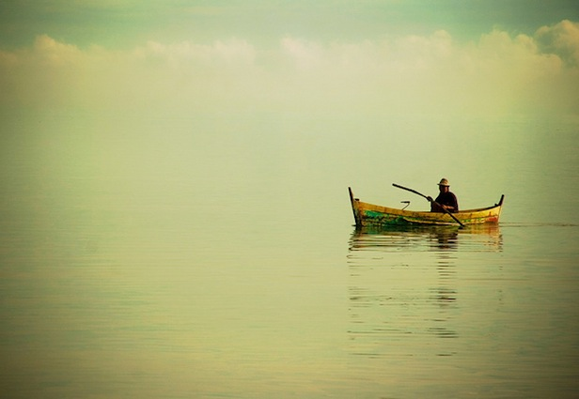
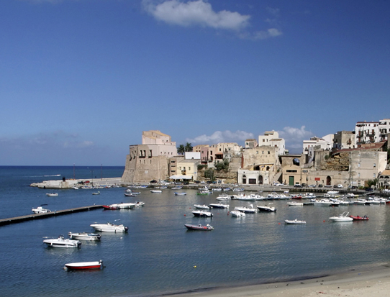
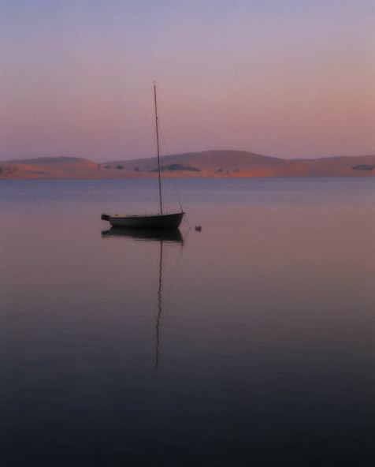
“4 Stars”
- LA Times
you read the book. It should include loads of detail. Remember - - avoid plagiarism!!!
Although it is a short book, it does take a little time to get moving. The scenery doesn’t change much and you have to be quite patient, especially when you’re waiting for Santiago to make his big catch.
People should read this book because it inspires you to work hard and to never give up no matter what the circumstances. Santiago was an old old man who could have easily given up, but he persevered and gained the respect of his entire town.
REVIEWS
This is where
you would
put the summary
of your story. The
beginning, middle,
and ending. It should
be detailed with enough
information that will
give me a good idea that
Based on the novel by Ernest Hemmingway
“A man can be destroyed, but not defeated.”

the
Old Man
and the Sea

