Freshman Honors Due Date: ___________________
Summer Reading Book Project
iTunes ALBUM

REQUIREMENTS:
Album Cover (10)
- Original artwork that depicts part of the setting of the book. *It must not be the book’s cover.
- A paragraph that describes the chosen setting, along with an explanation of its significance to the story
- An album title that best symbolizes the main idea of the story.

Song List (15)
- Create at least 15 songs that chronologically represent the book’s storyline.
- Songs cannot be the title of the chapters.

Sample Song Lyric (10)
- Create a sample of a song lyric that could best embodies the traits of a main character.
- Identify the main character and title of the song.
- Have at least 2 verses and the chorus of the song.

Artist (10)
- Choose a main character and describe their inner and physical traits in detail. Explain how you know this about the character.
- Describe an inner trait change the character went through and what caused the change.

Example
Author’s Name
TITLE of BOOK
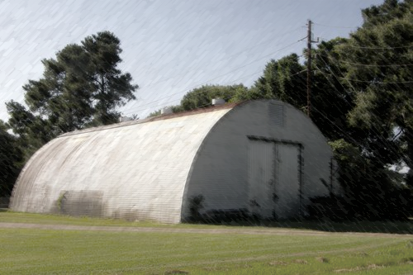
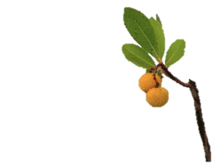
The paragraph should describe in detail the setting that you have chosen for the picture. It should also state the significance of choosing this particular setting. Please keep it to one to two paragraphs.
Name Artist
1. Lost Memories
2. Concrete Highway
3. A New Beginning
4. When Lightning Strikes
5. Freaks in a Show
6. IEP = Restriction
7. When it rains, it pours and sinks
8. Tangerine, Tangerine
9. War Eagles Rock
10. It’s Never What You Think
11. Frostbite
12. Poison Runs in My Blood
13. Viva Luis
14. The Truth Sometimes Hurts
15. Golden Dawn

Sample Lyrics
Freaks in a Show
Character: Paul Fisher

Verse 1:
The circus is in town.
Lights, faces, laughter,
Wandering all around.
People seem to enjoy
Fitting in with the crowd,
Where do I?

INSERT VERSE 2 HERE

Chorus:
Mirror, mirror
What do you see?
Why do I feel like my reflection is
What other’s think.
Am I a freak?
A freak in a show
On display for all to know.
GOLDEN DAWN
This section should describe in detail the traits of one of your main characters. Explain how you know this.

In a couple of paragraphs, describe their 1. personality, 2. physical appearance, 3. personal change they went through, 4. what caused the personal change.
Songs Ratings & Reviews Related

